

FERM 502 FINAL PROJECT

EMİR EĞİLLİ

ZİYA YİĞİT ATALAY

BURAK KARGIN

**Data Preparation:**

We carefully selected and gathered the daily trading data for our project from **Netflix (NFLX)** and **Amazon (AMZN),** two well-known S&P 500 Index components. To ensure a strong foundation for our financial modeling, we included the **10-Year Treasury yields** as a basic part of our study, serving as a stand-in for the risk-free rate.

To acquire the necessary market data, we leveraged the comprehensive resources provided by Yahoo Finance, retrieving historical stock prices spanning a period of one year. Subsequently, employing Microsoft Excel as our analytical platform, we meticulously computed the daily returns of both NFLX and AMZN stocks. This meticulous data preparation stage was pivotal in laying the foundation for our subsequent trading strategy formulation.

**Trading Strategy Selection:** Informed by a comprehensive review of contemporary financial literature and drawing upon insights gleaned from academic discourse, we deliberately opted for a Bull Call Spread strategy. This strategic choice was underpinned by its well-documented efficacy in leveraging directional market expectations while mitigating downside risks.

**NFLX Stock Strategy:** Within the framework of our Bull Call Spread strategy, we initiated a position on NFLX stock by purchasing call options with a strike price of $500. Concurrently, we adopted a prudent risk management approach by selling call options with a strike price of $520. The decision to execute an equal quantity of 500 contracts for both the purchased and sold options was predicated on achieving an optimal risk-return profile.

**AMZN Stock Strategy:** Similarly, for AMZN stock, we meticulously structured our Bull Call Spread strategy by acquiring call options with a strike price of $3200. Concurrently, we adopted a balanced approach by selling call options with a strike price of $3300. Aligning with our risk management framework, we executed an equal quantity of 200 contracts for both the purchased and sold options.

**Risk Management and Greeks Calculation:** Recognizing the intrinsic complexities of derivative pricing and risk management, we conducted a thorough analysis of the Greek parameters including delta, gamma, theta, vega, and rho. These calculations were meticulously performed within the confines of our Excel spreadsheet, facilitating a granular understanding of the dynamic interplay between option prices and underlying asset movements. Such rigorous quantitative analysis served as a cornerstone in informing our decision-making process and optimizing our trading strategy execution.

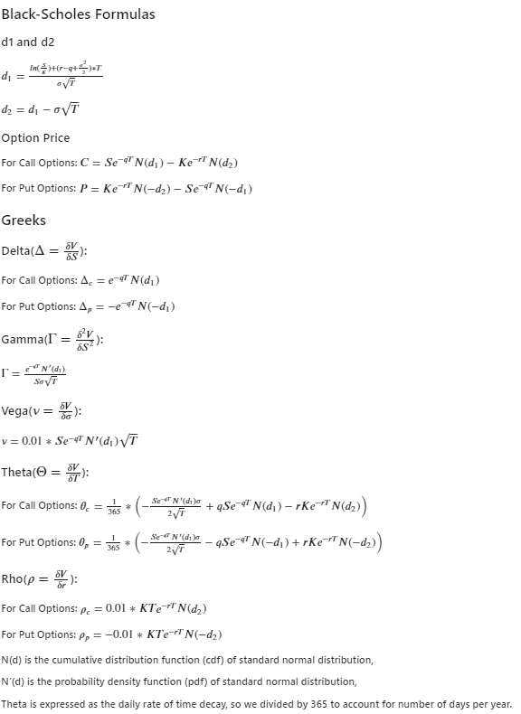

Take Long with 380 NFLX strike price

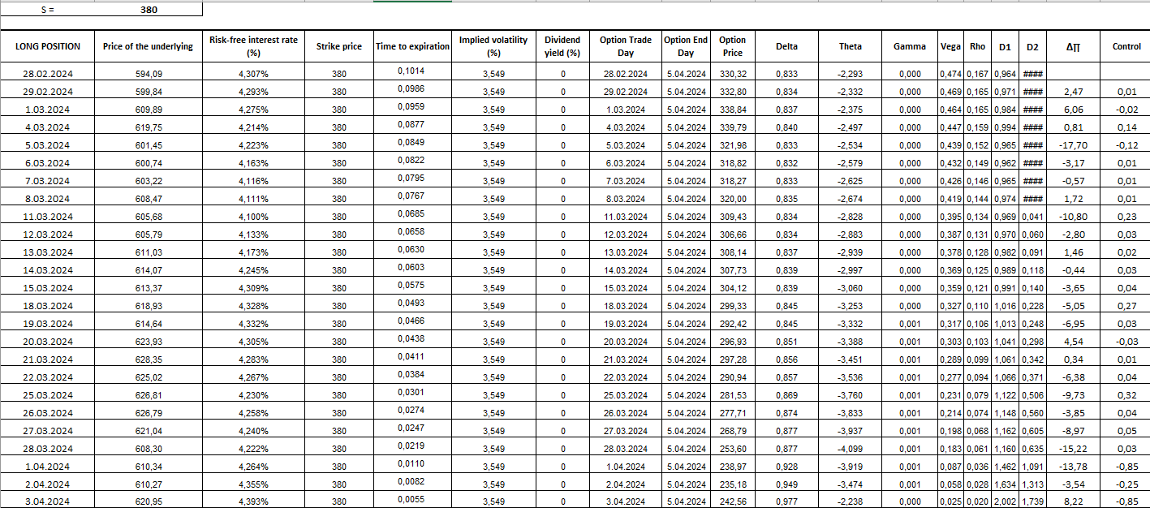

Take Short with 460 NFLX strike price

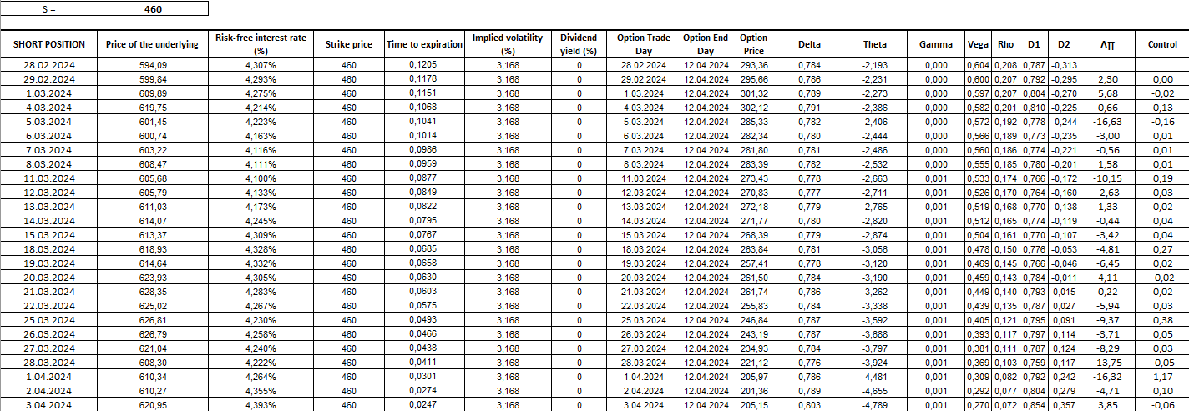

Take Long with 515 AMZN strike price

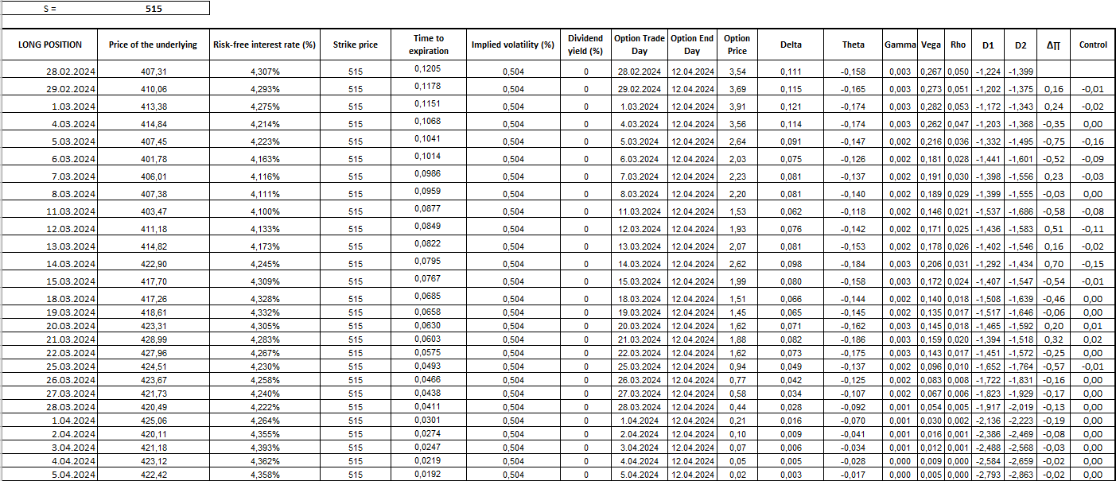

Take Short with 520 AMZN strike price

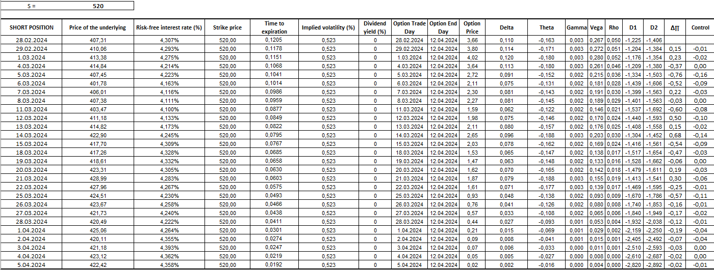

During the selected time interval, the performance of the Bull Call Spread strategy involving Netflix (NFLX) and Amazon (AMZN) exhibited several characteristics worth discussing. As it can be seen from the tables, the exact gain / loss measured by the amount of changes in the options prices are very close to predicted gain / loss calculated by the equation consisting of Greeks.

**Shortcomings/Advantages of the Strategy:**

**Advantages:**

Limited risk: Bull Call Spread strategy inherently limits downside risk since it involves buying a call option (lower strike) and simultaneously selling another call option (higher strike), reducing the overall cost of the position.

Potential for profit: If the price of the underlying asset (in this case, NFLX and AMZN) rises, the strategy can yield profits due to the long call position.

Defined maximum loss: Since the maximum loss is capped at the net debit paid to enter the spread, there's clarity on the worst-case scenario.

**Shortcomings:**

Limited profit potential: The maximum profit is also capped and occurs when the price of the underlying asset reaches or exceeds the higher strike price.

Sensitivity to timing and magnitude of price movements: Bull Call Spread strategies require precise timing and magnitude of price movements to achieve optimal results. If the price doesn't move sufficiently or moves in the wrong direction, the strategy may underperform.

Vulnerability to volatility changes: Changes in implied volatility can impact the value of options, affecting the overall profitability of the strategy.

**Performance During Significant Events and Periods of Volatility:**

**Market Events:**

During periods of significant market events such as earnings announcements, economic data releases, or geopolitical tensions, the performance of the option portfolio may experience heightened volatility.

Earnings reports, in particular, can lead to substantial price movements in stocks like NFLX and AMZN, impacting the profitability of the strategy.

**Volatility Impact:**

Periods of increased volatility can have both positive and negative effects on the option portfolio.

Higher volatility generally increases the value of options, benefiting the long call position. However, it can also increase the cost of the options sold, reducing the net profit potential.

Conversely, low volatility environments may result in reduced option premiums, affecting the overall profitability of the strategy.

In conclusion, while the Bull Call Spread strategy offers advantages such as limited risk and profit potential, it also comes with limitations related to profit caps and sensitivity to market conditions. Understanding these dynamics and effectively managing risk are essential for navigating the performance of the option portfolio during significant events and periods of volatility.